# Integrating Sendgrid Service

# Sendgrid Integration With Python Code

|  |  |
| --- | --- |
| Date | 27 October 2022 |
| Team ID | PNT2022TMID29836 |
| Project Name | Customer Care Registry |

**Step 1.** Overview

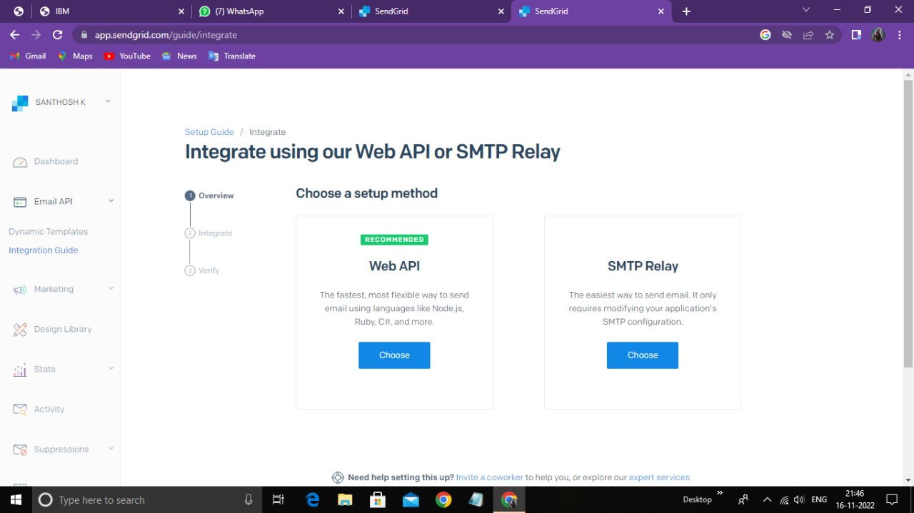

**Step 2**. Integration With Python

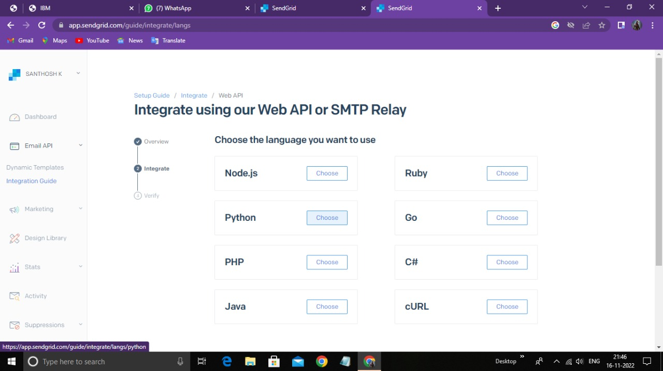

**Step 3**. Api Key

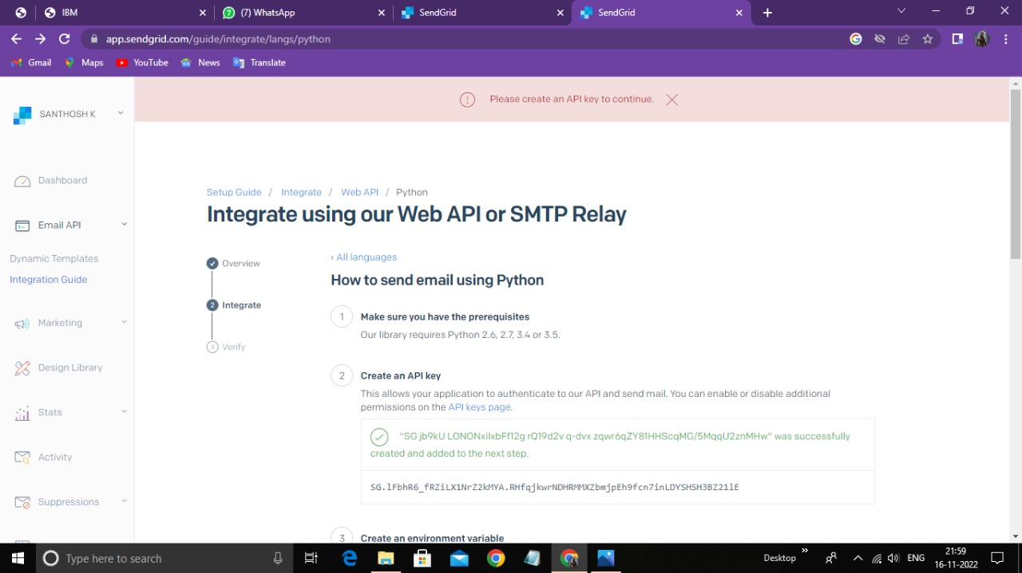

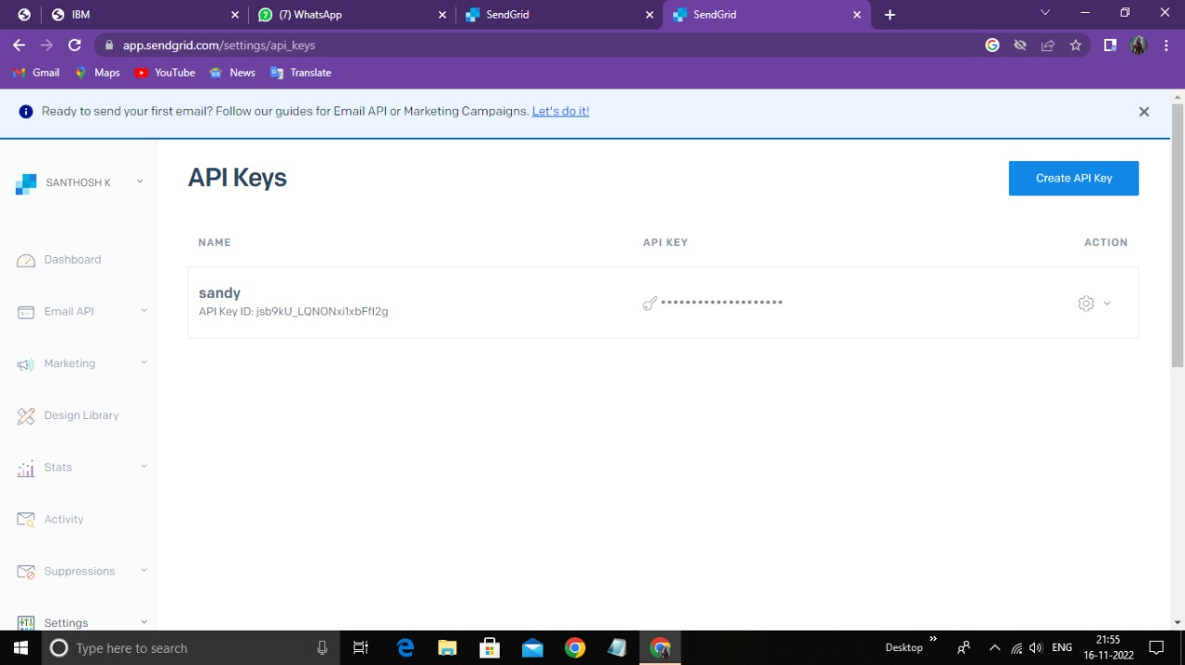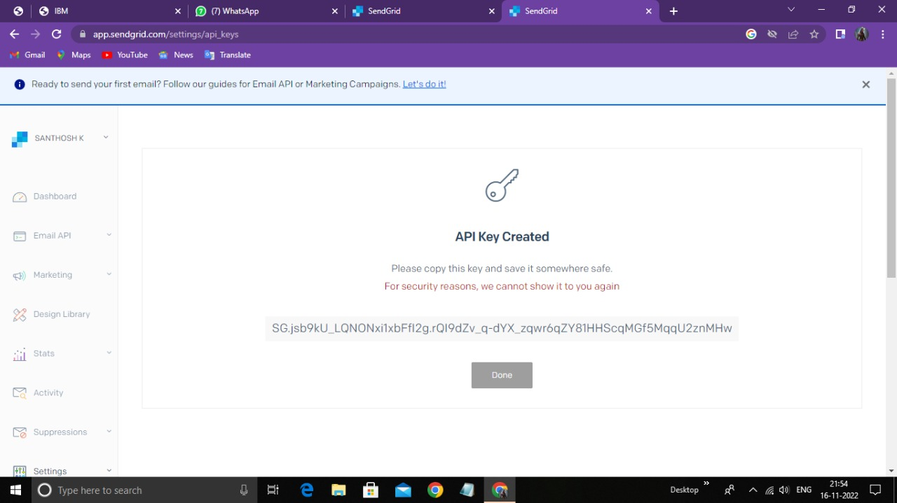

**Step 4**. Verification & Email Send

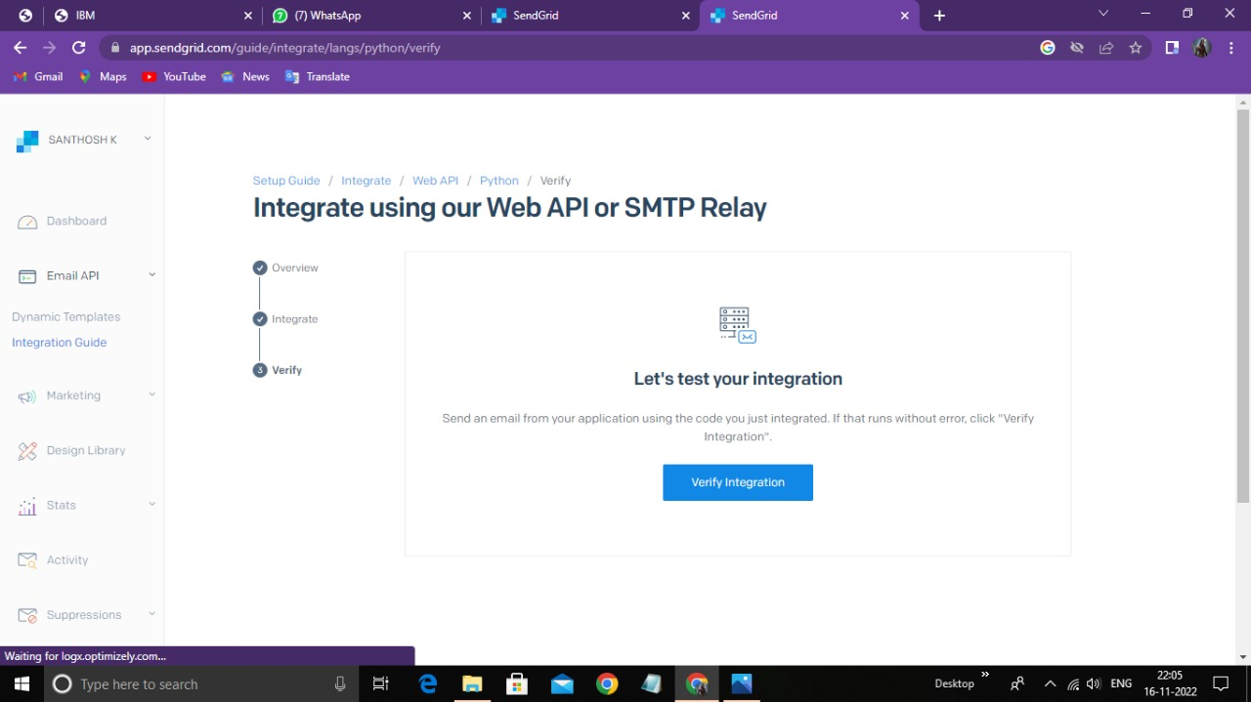

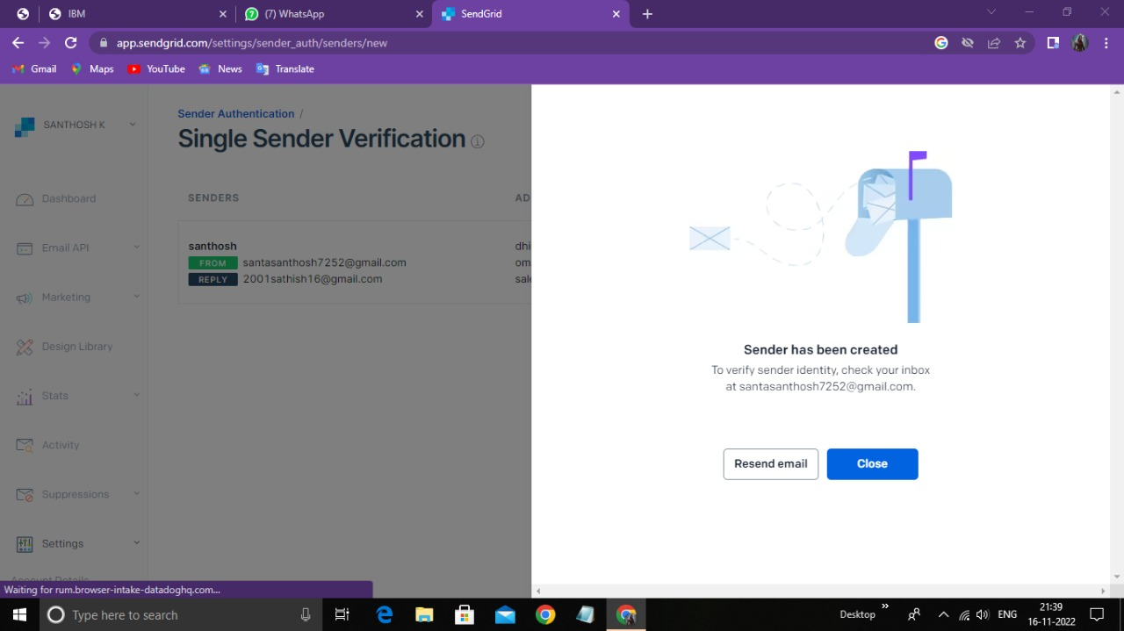

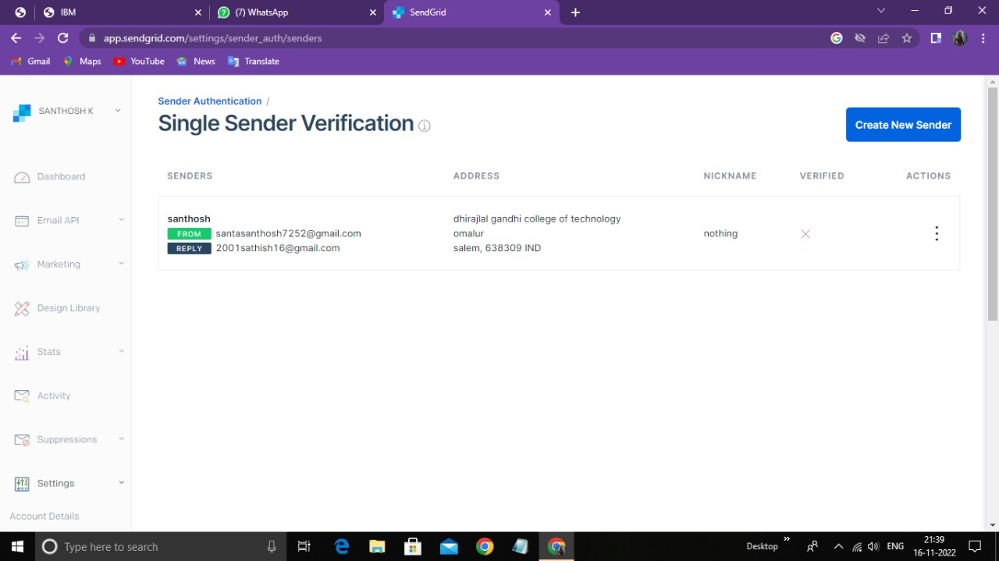

# OUTPUT:

Integration with Sendgrid using python code is executed Successfully